GEN B168F
You have a choice:
Career decision-making

Assignment 2

Student Name: Angold, Jiawei Wang
Student ID: s12395870

Tutorial Group: T04
Submitted to: MS Amy Chan
Date of Submission: 18 Dec 2020

1
Overview

My name is Jiawei Wang. A year-2 student in the school of science and technology.
After the assignment 1, which comes from the estimation to me. I think there must have some limitation in that estimation, because in that assignment, I am just considering the personality and future ability about myself, but do not think about what other people would think about me, or how excellent they are.

In this assignment, I’ll try to assess the outer world and work out a more detailed and practical plan about my future careers.

1. The outer world
In the Assignment 1, I made a brief introduction to the job market of IT.
At that time, I believe that because it is a special high-technology industry, it is constantly changing with the fastest speed ever. So, I must keep learning to avoid being eliminated.
But I ignore a fact ---- a large part of the people they do jobs which is full of repetition and meaningless ---- just like the worker who moving bricks again and again.

In mainland china, this phenomenon becomes more and more popular these days.
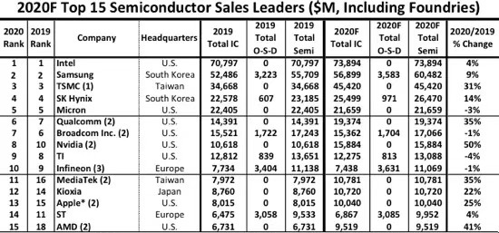
Figure 1 from angold4.com which represent that in Semiconductor industry, China did not get the high-end company
In my opinion, because China has always been catching up in the IT industry, it is a fact that these years we made a great progress in IT, but most of them were based on other countries’ achievements in the last 100 years. Which means we need to focus on fundamental subjects instead of doing things can only make money ---- like researching the algorithm of recommended shopping or how to push advertisement to users.

In China, it is a fact that the abnormal competition is increased these years.
We have the most talented and hardworking students in the world, in other worlds, we have no shortage of talents. This circumstance is great but also bad: If a talented student hardly finds a job but this job will cost 14 hours per day of his life. Which means he don’t have time to study and stay with his family. If the job is very challenging or it is a researching job, it is okay. But the truth is that most of companies in china were not. [1]
2
I think the main reason is that:
Most capitalists lack a sense of social responsibility.
“If a work can be done poorly with one staff, then it is needless to hire more people.”
“If this project can bring much profit, we will do it. If not, no matter how helpful to the society or their staff, of course we won’t.”

For me, I am a pure emergent person. What I will change is that I’ll not got married and keep learning till I can find a job with my expectation. Because in most cases, “Responsibility” is equal to “do things you are not expected”. I have 0 confidence that I can get a balance among family, learning and working just after graduation (even with PhD degree).

2. The inner career
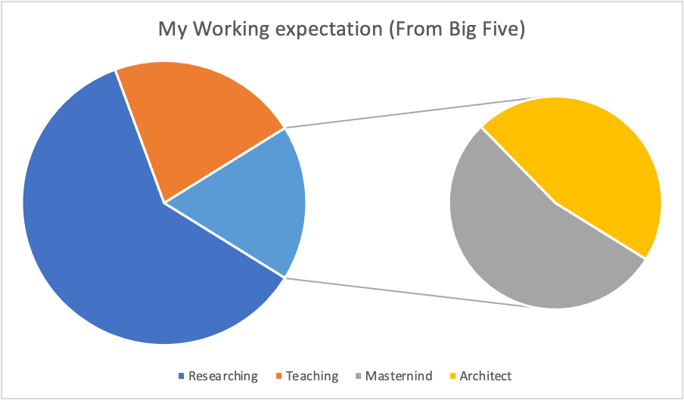
In Assignment 1, I write that I am a person who cares about the feelings of others.
But when meeting significant things. I will unswervingly follow my heart.
The situation is changeable, especially in the next 10 years. The speed of development has slowed down, and social conflicts have intensified. Only the person who has unique and competitive ability, the person who take no responsibility, or their family has a lot of money can live well. Especially in China.

In my opinion, this world has never been a society where the strong eat the weak, also, this world shouldn’t be a society where the strong helps the weak.
Because every people have their own pursuit, and their own expectation to their life, when we help others, the first thing we need to consider is that whether the “weak” is needed for our “strong” help.
I think this society should only have one requirement – everyone is equal.
Which means everyone enjoy the same opportunity to do what they really want, and everything in their life based on their choices – although they have different position.
In my younger ages, I used to want to change the world – maybe to invent something as a scientist, or maybe bring a sense of honor as a member of this country.
3
But now I discovered that these things if I do not do, there are many other people who really have motivation and interest will finish it – and may be better than me (because they have interest).
Then I realized all I want is something that accompanies these achievements, not the achievement itself. So now, I do not put “changing world” as the motivation myself but do things I really want.

Luckily, it is not late that I found being a software engineer is very cool, I feel satisfied when programming or build my own tools with code. So, no Person-job fit, no matter how hard it is, I will achieve it – “being a software engineer in a company that I like” for myself.

In detailed, the most happiness thing for me is that this job or hobby can bring me a [2] substantial income which can help me take care of my family and have time enjoy my life.
“Being a software engineer in a company that I like” may looks not detailed. I think I am a pure emergent person, “Undetailed” and “I like” is usually not conflict for me. It depends on what I will thought in the future.

3. The action plan

For today’s me, it is hard to achieve this goal.
There are 3 obstacles that I may encounter in my career:
1. The skills that was excellent or different from other in the same industry
2. The responsibility that I need to take – like parents, the living outcome.
3. My own limitation – Ability, Intelligence

For these obstacles, here is my suggest way to overcome:
1. Try my best to study, but need to follow the advices from experienced seniors
2. If can, got the PhD degree.
3. Try to find jobs that won’t cost many times, which can leave me much time to study.
4. Enjoy the life, and put the passion of this goal into everyday life
5. Never regret.

Reference:

[1]. https://www.nytimes.com/2019/04/29/technology/china-996-jack-ma.html - commentsContainer

[1`] Goldberg LR (January 1993). "The structure of phenotypic personality traits". American Psychologist. 48 (1): 26–34. doi:10.1037/0003-066x.48.1.26. PMID 8427480.

Thanks.

4

